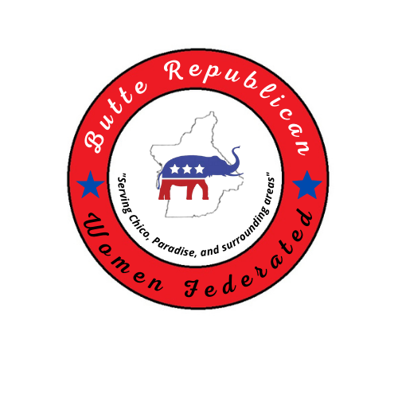
2022 REGISTRATION FORM

"When she speaks, her words are wise, and she gives instructions with kindness." Proverbs 31:26
T Y P E O F M E M B E R S H I P
MEMBER $50.00 ____ ASSOCIATE $25 ____ CHECK # _____ DATE _____-_____-____ CASH$________
MAKE CHECKS PAYABLE TO: BCRWF
SEND TO: PO BOX 5439, CHICO CA 95927
NAME _________________________________ BIRTHDATE ____/_____ (DAY & MONTH ONLY) EMAIL______________________________STREET ADDRESS ___________________________________ CITY/STATE__________________ ZIP ____________HOME PHONE _____________________
CELL ____________________ (MUST HAVE AT LEAST ONE)
REGULAR MEMBER OF ANOTHER FEDERATED CLUB? YES ____ NAME: ____________________NO _____

MEMBERSHIP BENEFITS:
-Nine no-host luncheon meetings per year, featuring topical speakers, and/or Republican office holders or candidates addressing current issues. - Monthly newsletters featuring the latest club information, Women’s Federation events, Conservatives articles, legislative updates/alerts, and volunteer opportunities. -Membership in the California and National Women Federation. - Regular updates on local and national political activities and elections - Opportunities for seminars and conferences to gain information and knowledge of principles and practices of the Republican Party - Information for election vote, fundraisers, and club-sponsored community service activities at a grassroot level.

INTERESTS: Tell us in which areas you are interested in volunteering:
__First Vice President in charge of speakers for Programs ––Second Vice President in charge of Membership__Third Vice President in charge of ways and means __Fourth Vice President in charge of Campaign & Precinct Activities__Recording __Secretary__Communications Network___Chair_Voter Registration___Treasurer___Parliamentarian___Americanism___Publicity___Chaplain___Sunshine ___Legislature
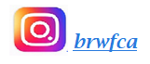
Follow us on:

